**St Mawes Sailing Club**

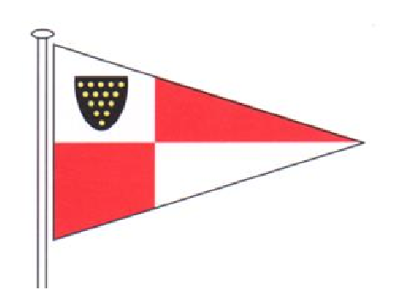

**1 The Quay, St Mawes, Cornwall. TR2 5DG**

**Tel: 01326 270686 E-mail: membershipsec@stmawessailing.co.uk**

**Application For Membership**

|  |  |
| --- | --- |
| Main Full Member: | Telephone Number: |
| Address: | Mobile Number: |
|  | E-mail: |
|  |  |
|  |  |
| County: | **Proposed by:** |
| Post Code: | **Seconded by:** |

|  |  |
| --- | --- |
| Joint Full Member: | Other Full Member: |
| Mobile Number: | Mobile Number: |
| E-mail: | E-mail: |

|  |  |
| --- | --- |
| Junior Member (Under 18 years of age) | Junior Member (Under 18 years of age) |
| Name: | Name: |
| DOB: | DOB: |
| E-mail: | E-mail: |
| Mobile No.: | Mobile No: |
| Young Adult (Over 18 and under 25 years of age) | **Young Adult (Over 18 and under 25 years of age)** |
| Name: | Name: |
| DOB: | DOB: |
| E-mail: | E-mail: |
| Mobile Number: | Mobile Number: |

**Subscriptions Types**

|  |  |
| --- | --- |
| Full Membership (Adult 25 years of age or over) £100.00 | Young Adult (18 to under 25) £25.00 |
| Joint Full Member (Couple living at same address) £155.00 | Junior Member under 18 sponsored by a full member £10.00 |
| Associate Membership is also available by approval of the General Committee for those born, bred and living on the Roseland  Please contact the Membership Administrator for further information | |

**The Main Full Member will be responsible for the subscriptions of all those named on the application form.**

**I confirm payment by B.A.C.S. to St Mawes Sailing Club Ltd, Lloyds Bank sort code 30-98-57 Account 27121268, to cover the first subscription after which I will pay all subscriptions and dues by Direct Debit via Go Cardless. Please log into your club account on the website to approve Go Cardless payments via the online portal or contact the Membership Administrator who will be happy to assist you with this.**

**By applying for a subscription, you explicitly consent to St Mawes Sailing Club Ltd holding and using your personal data. Please read our privacy policy at www.stmawessailing.co.uk/privacy-policy to understand how we will manage your data.**

|  |  |
| --- | --- |
| **Main Applicants Signature** | **Date** |

|  |  |  |  |
| --- | --- | --- | --- |
| **BOAT NAME** | **MAKE (e.g. Sadler 26 )** | **CLASS (e.g. dinghy, cruiser)** | **Sail Number** |
|  |  |  |  |